DESIGNING PROFESSIONAL BUSINESS CARDS

Project Report Template:

INTRODUCTION

1.1 Over View:

**Business cards** are [cards](https://en.wikipedia.org/wiki/Card_stock) bearing business [information](https://en.wikipedia.org/wiki/Information) about a [company](https://en.wikipedia.org/wiki/Company) or [individual](https://en.wikipedia.org/wiki/Individual).[[1]](https://en.wikipedia.org/wiki/Business_card#cite_note-1)[[2]](https://en.wikipedia.org/wiki/Business_card#cite_note-2) They are shared during formal introductions as a convenience and a memory aid. A business card typically includes the giver's name, [company](https://en.wikipedia.org/wiki/Types_of_companies) or business affiliation (usually with a [logo](https://en.wikipedia.org/wiki/Logo)) and contact information such as [street addresses](https://en.wikipedia.org/wiki/Address_(geography)), [telephone number](https://en.wikipedia.org/wiki/Telephone_number)(s), [fax](https://en.wikipedia.org/wiki/Fax) number, [e-mail](https://en.wikipedia.org/wiki/E-mail) addresses and [website](https://en.wikipedia.org/wiki/Website). Before the advent of electronic communication, business cards also included [telex](https://en.wikipedia.org/wiki/Teletypewriter_message) details.[[3]](https://en.wikipedia.org/wiki/Business_card#cite_note-3) Now they may include social media addresses such as [Facebook](https://en.wikipedia.org/wiki/Facebook" \o "Facebook), [LinkedIn](https://en.wikipedia.org/wiki/LinkedIn) and [Twitter](https://en.wikipedia.org/wiki/Twitter). Traditionally, many cards were simple black text on white stock, and the distinctive look and feel of cards printed from an engraved plate was a desirable sign of professionalism. In the late 20th century, technological advances drove changes in style, and today a professional business card will often include one or more aspects of striking visual design.

1.2. Purpose:

A business card is a highly personal form of marketing, and does exactly what you need it to. Business cards serve the key purpose of marketing your business and getting your key contact information into your client's hands… all in a matter of seconds. Fundamental to the value of the business card, is its portability.

**It Says A Lot About You**

A business card says a lot about your business, in more ways than one. A good card succinctly conveys what your business is all about. It tells someone what you do AND how they can get in touch with you. It shows off all your branding essentials: The name of your business, your logo, and your tagline.A good business card tells people something about you that isn’t written on the card: It speaks to your level of professionalism and preparedness. It can also show off your taste: A well-designed, eye-catching business card will make you look creative, innovative, and thoughtful. It’s a simple and effective way of standing out from the pack.

## It Offers A Personal Touch

Business cards are physical objects. They have a weight and presence that digital marketing just can’t compete with. You could send someone an email with all your contact info in it, but that’s going to feel more impersonal than handing someone a card. Emails are also easy to forget about: They can quickly get buried underneath an avalanche of incoming messages. A business card, on the other hand, sticks around. People will put them in their wallets, stick them in desk drawers, or even use them as bookmarks. This increases the chances that they will stumble onto your business card again. So even if someone doesn’t want to do business with you right now, if they hold onto your card there’s a good chance they’ll see it again and it will remind them about your business. Emails and other forms of digital communication don’t have that benefit.Another benefit that comes from business cards being tangible objects: They’re easy to pass around! It’ll be much easier for satisfied customers to spread the word to their friends if they can press one of your cards into their hands.

## It Gives You A Competitive Edge

“Don’t judge a book by its cover” is a great idea in theory, but the truth is that we as a society do the opposite all the time. Your business card can make or break your business. It’s as essential to establishing a good first impression as the clothes you wear to a meeting or the way you shake someone’s hand. If you’re in a creative industry, few things will turn off potential customers more than having a dull business card.

We’ve seen it firsthand. LOTS of companies out there don’t put a lot of thought or effort into their business cards. They produce cards that are standard and utilitarian: They give you all the information you need, but display nothing in the way of style or creativity. Having a unique looking card is a great way to get one up on your competition. A great business card may take a little extra time and money to produce, but the added effort will be worth it.

2. PROBLEM DEFINITION & DESIGNINIG THINKING:

2.1 Empathy Map:

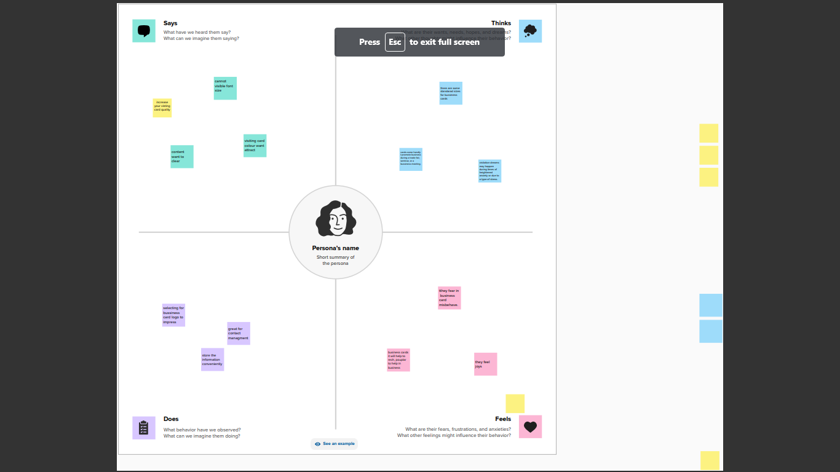

2.2 Ideation & Brainstorming:

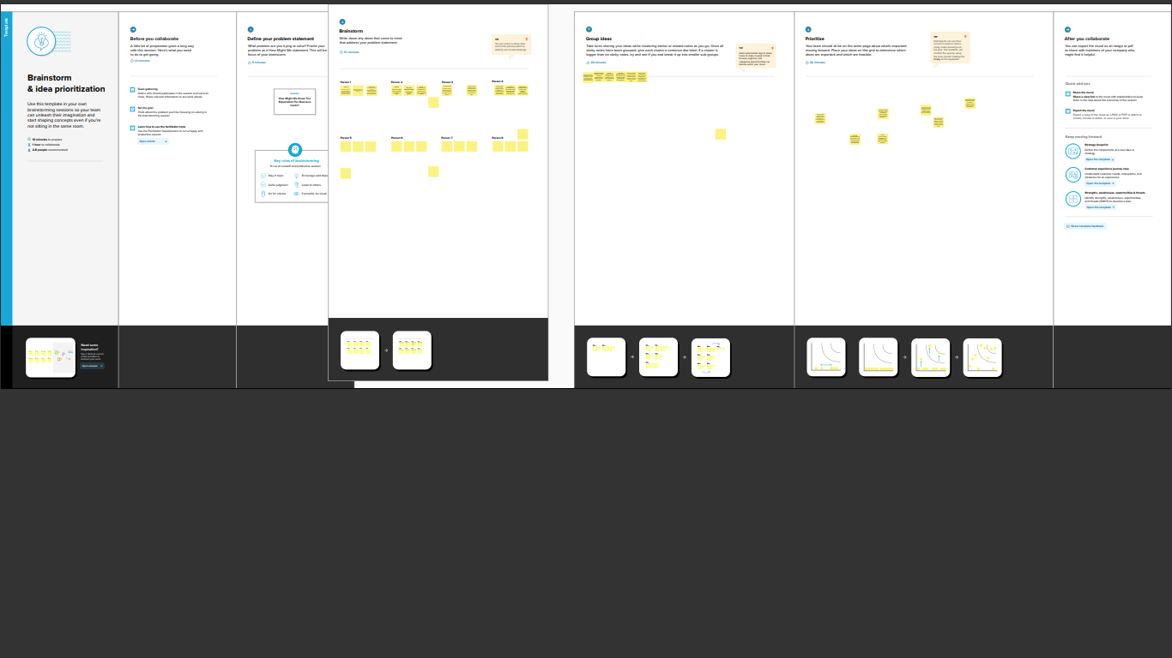

3 RESULT



4 ADVANTAGES AND DISADVANTAGES:

* The first benefit of using business cards is their affordability. When compared to other advertising options such as billboards or a digital marketing campaign, business cards are an extremely cheap choice.Despite their low price point, a business card is an excellent tool for increasing brand awareness and gaining more clients. A batch of business cards can access just as many potential clients as a billboard, and the nature of a physical card means they are more likely to leave a lasting impact
* If your company regularly attends networking events or trade shows, then a business card strategy is going to be extremely beneficial. You don’t want people to like and appreciate your work, but then forget what your brand was called when they get home.Placing a business card stack on your table is a great way to ensure that anyone who needs your contact information can get it with ease.
* The cost to design and print. Creating a design that stands out and gets you noticed often requires help from a professional Graphic Designer.
* They need to be kept up-to-date.
* They have limited information.

5 APPLICATION:

Hosting key business information, such as your website, email and phone number, a business card encourages people to contact you, visit your business (online or in real life) and learn more about you. Another way to encourage customers to engage — and hold on to your business card — is by adding an incentive.

6 CONCLUSION:

Through this project we learnt to create any types of business cards with canva. This project is useful to us to give a good performance in job.